**Texas Instruments Sensor2Cloud Linux – Getting Started Guide**

**Introduction**

This guide provides quick steps to run the out of box **Sensor2Cloud** example. This kit enables you to view and control sensors on a Sub1-GHz network from the cloud. All the devices in the kit are pre-programed with required software. The kit includes two methods of operation: a cloud connected gateway and a local gateway. The cloud connected gateway allows you to leverage cloud services such as [Amazon Web Services](https://aws.amazon.com/) (AWS) and [IBM Cloud](https://www.ibm.com/cloud-computing/). The local gateway allows you to run a gateway within a local IP network for privately managed networks that do not require external connectivity. It’s important to note that the design allows you to quickly add **any** desired cloud service.

* 5V Power Supply
* BeagleBone Black

**Kit Contents**

* BeagleBone Wireless Connectivity Cape
* FTDI Cable
* Pre-flashed MicroSD
* 2 x TI SimpleLink™ CC1350 LaunchPad™
* 2 x Micro-USB Type B Cable

The BeagleBone Black (BBB) comes equipped with a BeagleBone Wireless Connectivity Cape and pre-inserted microSD card with necessary software. Connect the BBB to the CC1350 LaunchPad labeled ***MAC co-processor*** as shown below. Connect the 5V power supply to the BBB and an electrical outlet. The CC1350 LaunchPad labeled ***Sensor*** should be connected using the provided USB to any USB power source. A blue LED on the BBB and a green LED on each of the CC1350 LaunchPads should illuminate.

**Hardware Setup**

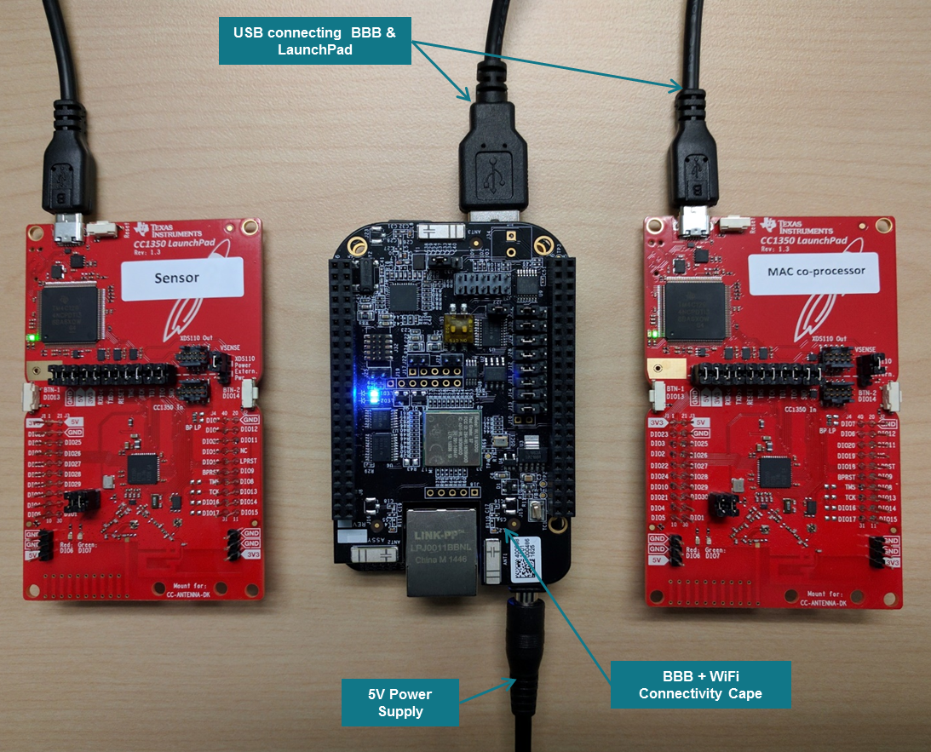

The BBB operates out the box as a Wi-Fi access point with SSID: ***Sitara AP***. Connect to the network with a PC by using the password: ***sensor2cloud***. Once connected, open a browser and type in the address bar: **http://*192.168.43.1:1310***. This will open the main Sensor2Cloud portal hosted on the BBB.

**Running the Demo**

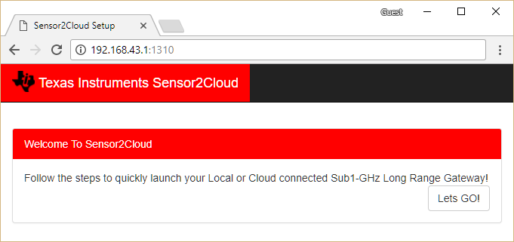

Select the method of operation for the demo:

* 1. **Cloud Connected Gateway**
     + Monitor and control the Sub1-GHz network using AWS or IBM Cloud Service.
  2. **Local Gateway**
     + Monitor and control the Sub1-GHz network using a local IP network for privately managed networks that do not need external connectivity.

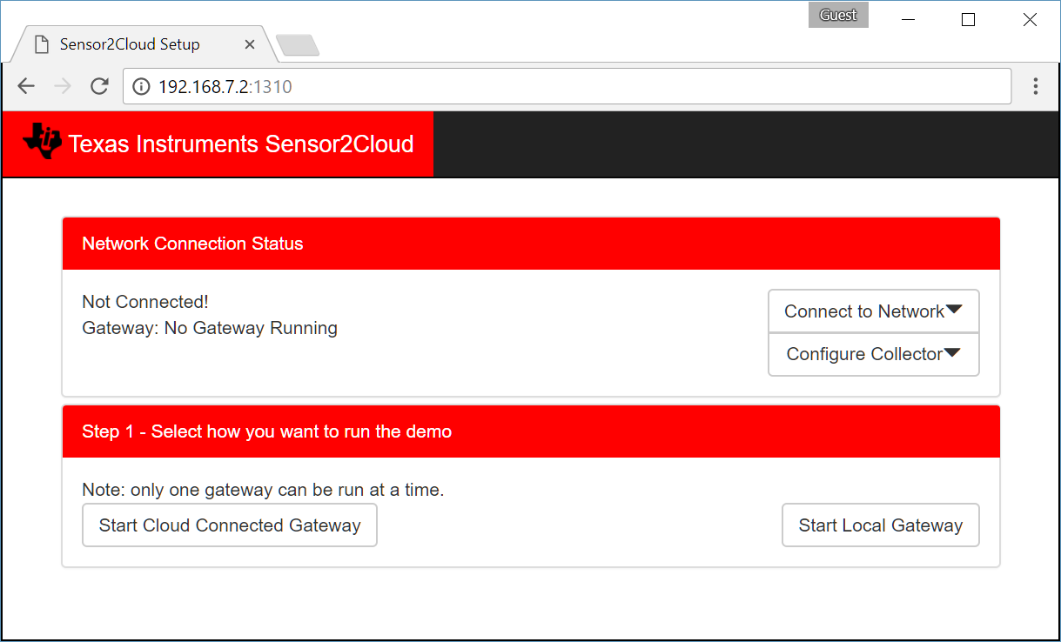

To run the cloud connected gateway, the BBB must be connected to the internet.

**Running Cloud Connected Gateway**

1. Select the ***scan for available networks*** drop down to begin a 10 second network scan. Selecting **Remember Network** will cause the BBB to automatically connect to the selected network when possible. This is true even after the device has been power cycled.

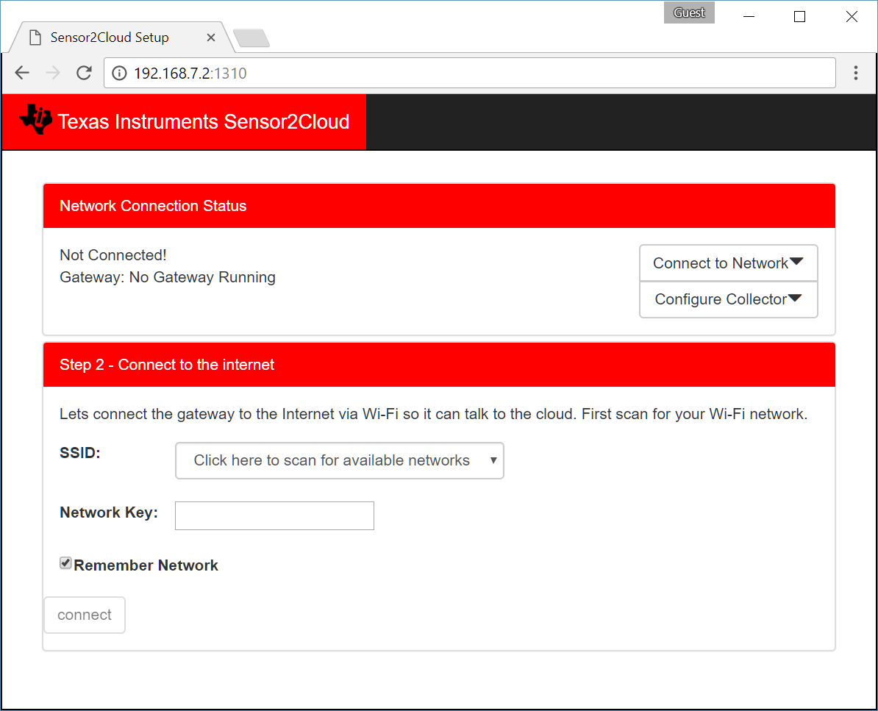

1. After successfully connecting to the internet, select the desired cloud service. Note that the ***Local Gateway*** option may be selected despite it not requiring an internet connection. Amazon Web Services (AWS) is provided through stackArmor.

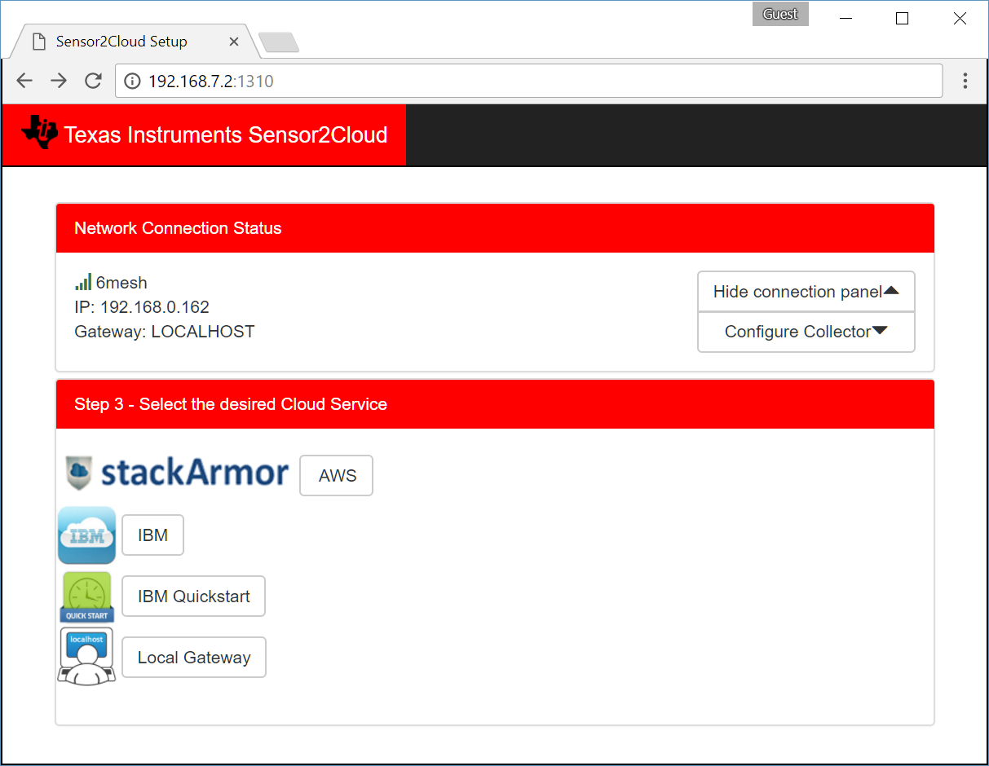

1. Request credentials from [stackArmor](https://www.stackarmor.com/iotdemo/).

**Using Amazon Web Services (AWS)**

* + If approved, stackArmor will provide the security credentials necessary for the steps below.

1. Use ***Choose File*** to upload the security credentials received from stackArmor. Click ***Submit*** to upload the selected files.

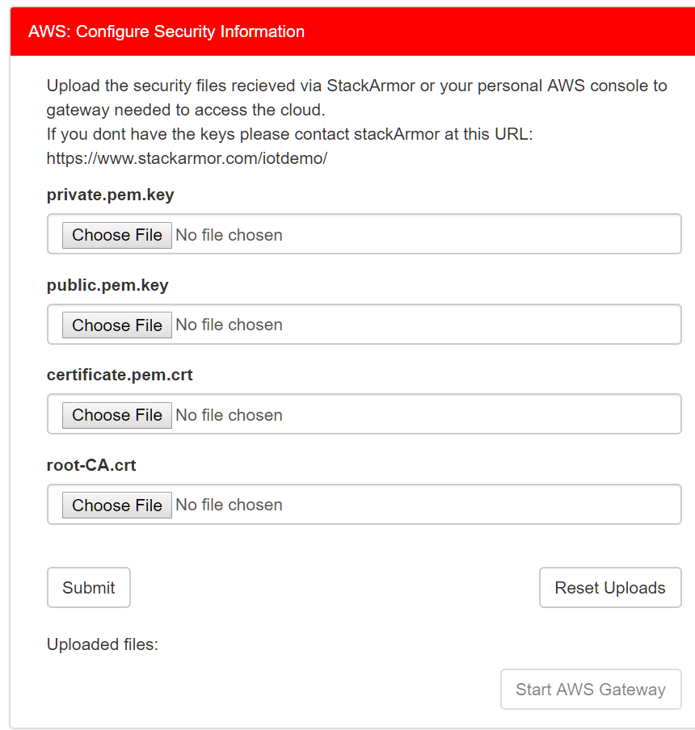

1. After successfully uploading the security files, select ***Start AWS Gateway***.
   * If prompted, enter the username and password provided via email from stackArmor.
2. Set the ***Network*** to ***On*** to allow the sensor(s) to join.

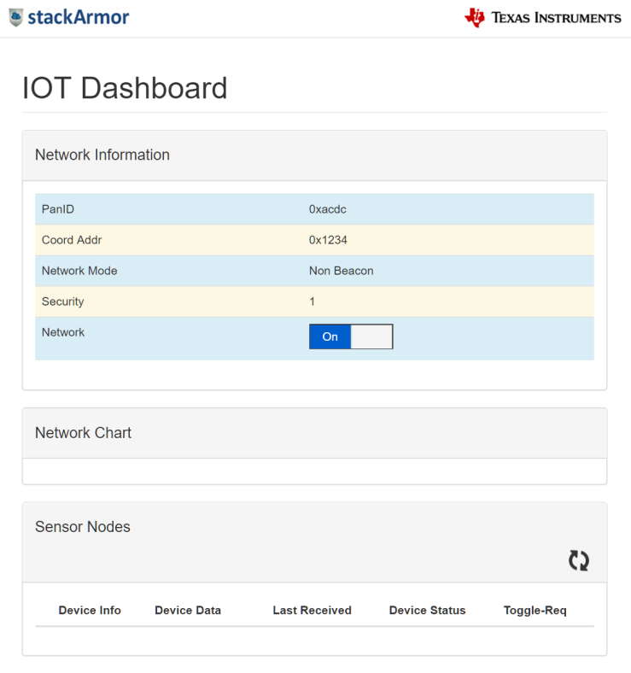

1. Power on the sensor(s), if not done so already.
   * The sensor(s) will automatically join the network and appear in the ***Network Chart*** and ***Sensor Nodes*** table.

**Using IBM Quickstart**

Selecting ***IBM Quickstart*** will launch an IBM Watson IoT Platform.

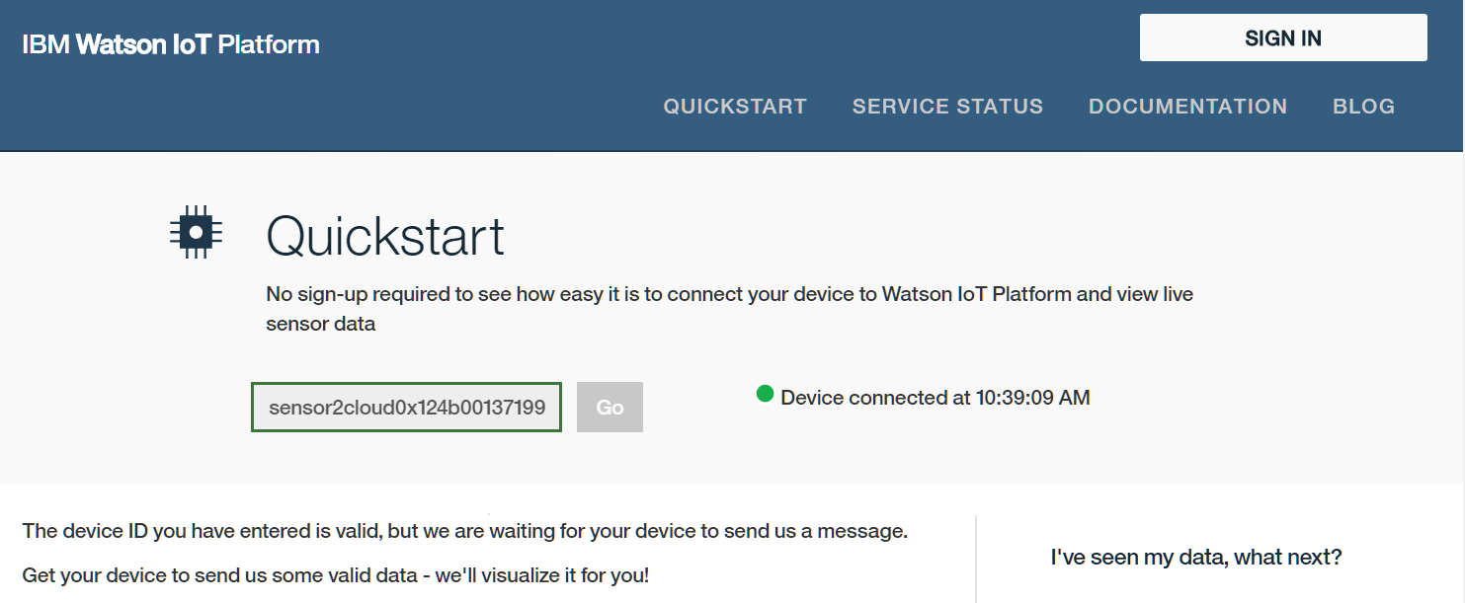

1. Power on the sensor(s), if not done so already.
   * The webpage will automatically update with the sensor data.
2. Select a sensor data point to see its value graphed. In the figure below, ***smart_objects.temperature.0.sensorValue*** is selected.

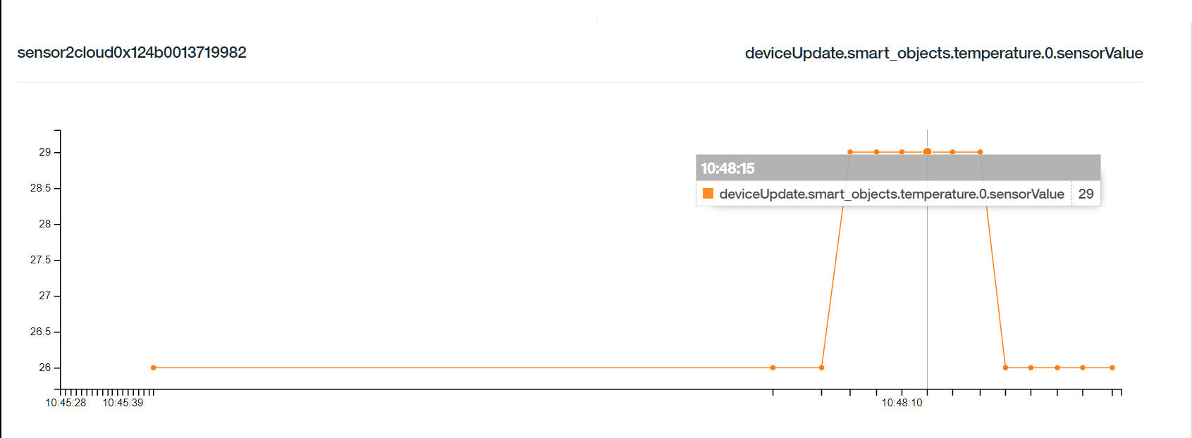

1. Download and install [Cloud Foundry CLI](https://github.com/cloudfoundry/cli#downloads).

**Using IBM Cloud Service**

* 1. Verify installation by typing the command, ***cf***, on the system terminal.

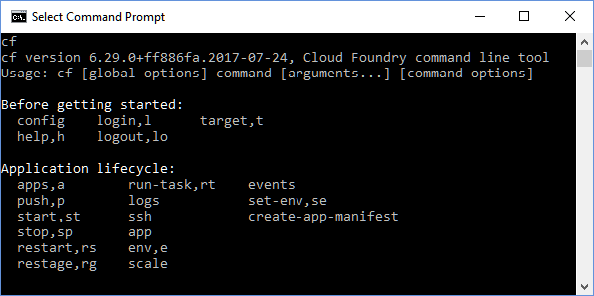

1. If you do not already have one, you will need to open and configure an IBM® Bluemix® Account.
   1. Create an [IBM Bluemix Account](https://console.bluemix.net/) and register a 30-day trial account.
   2. Confirm the Bluemix account using the link provided by IBM through email.
   3. Log into the Bluemix account.

[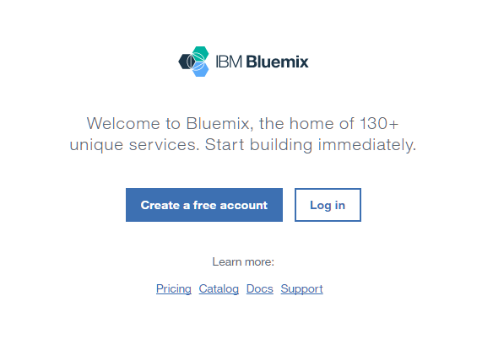](https://console.bluemix.net/)

1. Create a service.
   1. From the [IBM BlueMix Dashboard](https://console.bluemix.net/), select ***Catalog*** from the upper right hand corner.



* 1. On the left hand menu, select ***Internet of Things***.

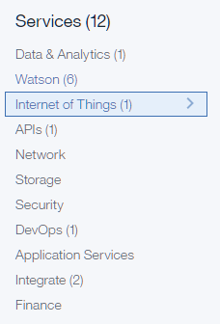

* 1. Now select Internet of Things Platform.

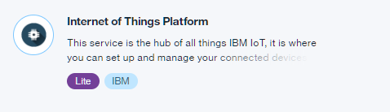

* 1. For this guide, use *myService* as the ***Service name***, though any name may be used. The service name will be used later on in this guide. The **Lite** pricing plan should be pre-selected and is free for trial users. Click ***Create***.
  2. Select ***Launch***.

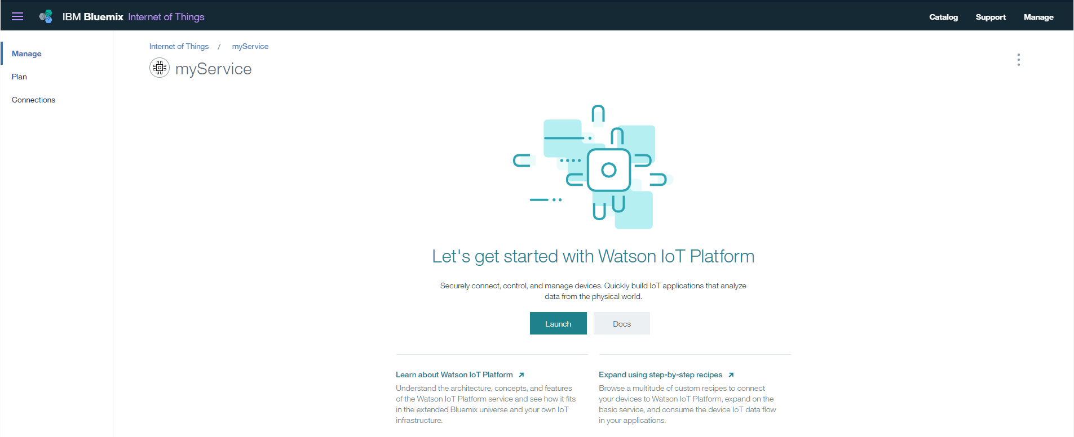

* 1. From the right hand menu, select ***Devices*** and click ***+ Add Device***.

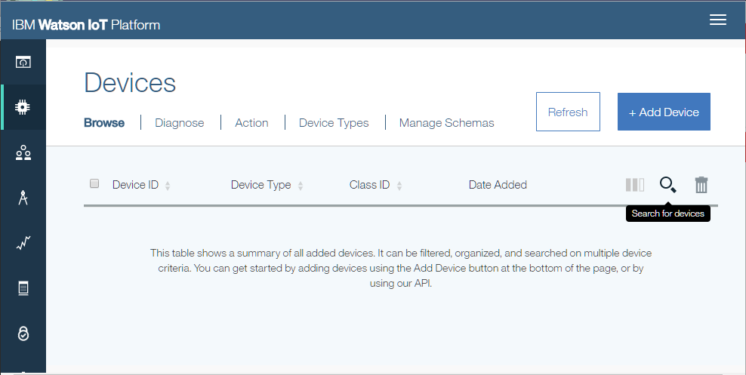

* 1. Select ***Create device type*** and ***create gateway type***.

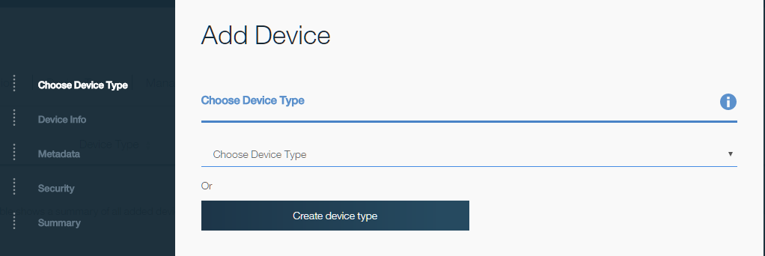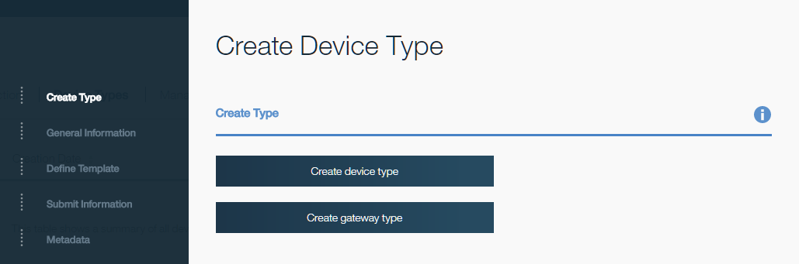

* 1. Enter *gateway* as the ***Name*** and add an optional description. Select ***Next*** in the bottom right hand side.

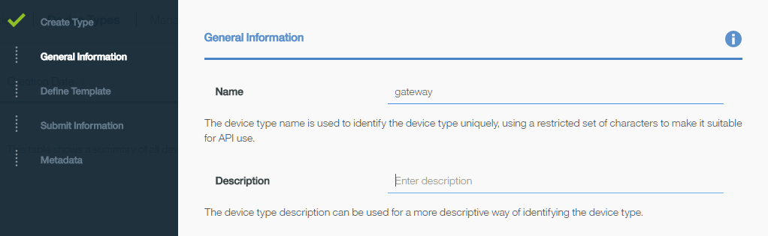

* 1. Select ***Next***—ignoring the subsequent options—until reaching the ***Add Device*** screen seen in step 3.7. From the ***Choose Device Type*** drop down menu, select *gateway*. Click ***Next***.

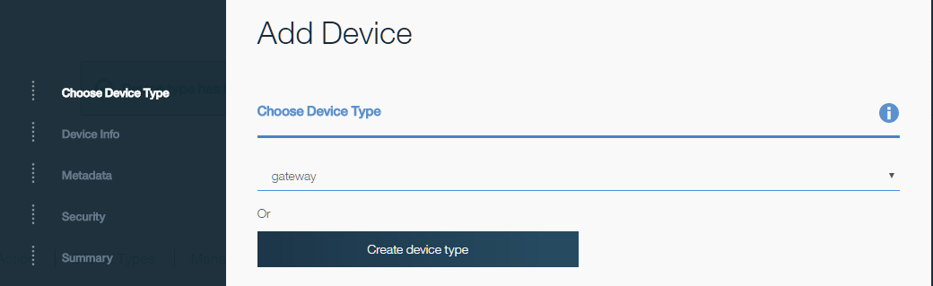

* 1. Enter a ***Device ID***. Take note as the Device ID used as this will be needed in a later step. This guide uses *myGatewayDevice*. Click ***Next*** until reaching the ***Security*** step.

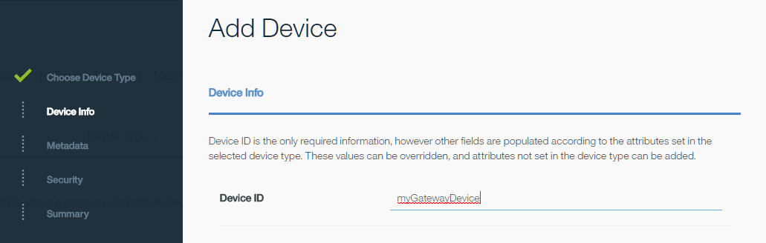

* 1. Enter a token. Take not of the token used as this will be needed in a later step. Click ***Next***.

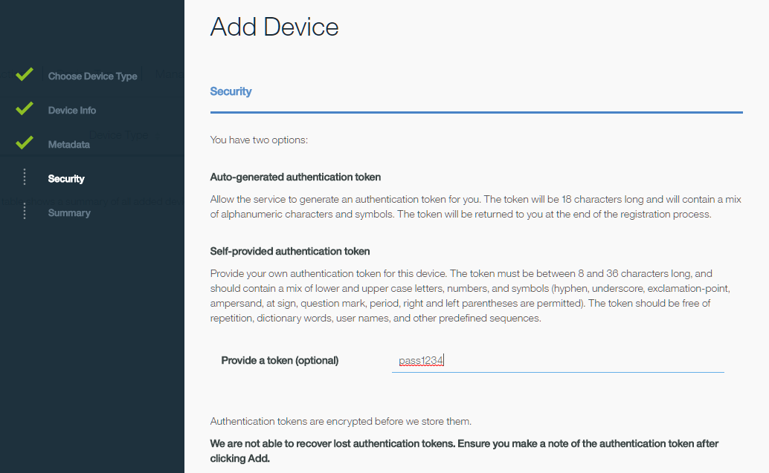

* 1. Use the Summary view to verify the ***Device ID*** and ***Authentication Token***. Use the ***Back*** button in the bottom right hand side to return and edit any items. When done, click ***Add***. Your device credentials will be displayed.

1. Upload the provided Cloud Foundry App.
   1. Unzip the provided <filename>.zip.
   2. Navigate to <folder>/<subfolder> and use a text editor to modify the ***manifest.yml*** file. Select a ***name*** and unique hostname (***host***). The ***host*** will be used to generate a unique link to your cloud application. You will be able to tell if your selected hostname is already used in step 4.4. Add your service name to ***services*** using the service name from step 3.4.

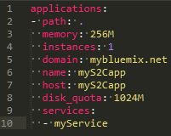

* 1. Open a system terminal and navigate to the <subfolder> directory. Enter the command, ***cf api https://api.ng.bluemix.net***. Then use the ***cf login*** command and login with your account credentials created in step 2.

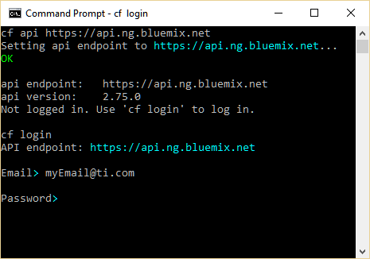

* 1. After successfully logging in, use ***cf push*** to upload the application. Note that if a unique hostname is not used, an error message will be generated. In that case, return to the ***manifest.yml*** and modify the ***host*** and try again.
  2. Open the [IBM Bluemix dashboard](https://console.bluemix.net/dashboard). The application will now be visible under ***Cloud Foundry Apps***. Note that the route column displays a unique hostname for the application. Select the application by clicking the row—do not click the URL in the route column. This will open the application overview.

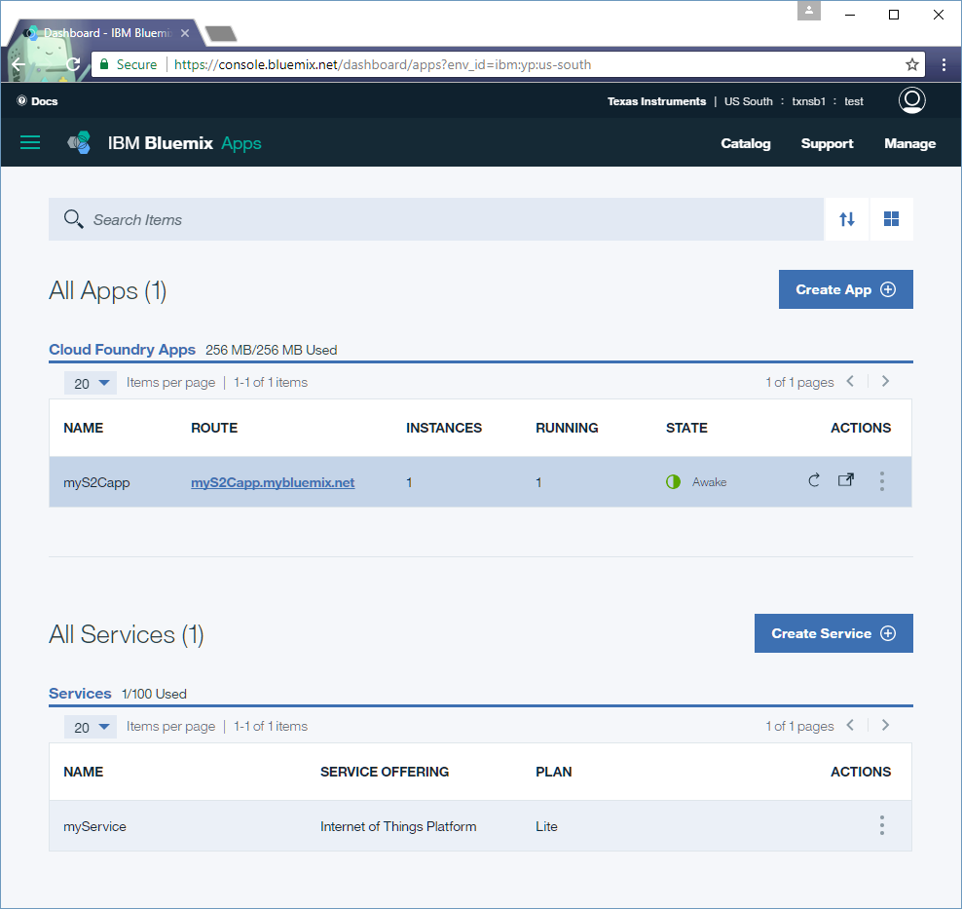

* 1. Click ***Connections*** in the left hand menu. The service created in step 3 should be visible. If not, use the ***Connect existing*** button to add the service.

1. Click **View credentials**. This will display all the information necessary to launch your BBB gateway.

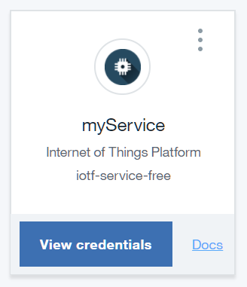

1. In another web browser window, access the BBB Sensor2Cloud portal and select ***IBM*** as the cloud service. Use the ***Org*** listed in the service credentials from step 5. For ***Type*** use *gateway* and ***ID*** use the device ID from step 3.10. Lastly, use the token created in step 3.11. Click ***Start IBM Gateway***.

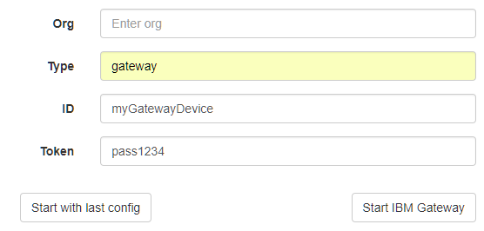

1. From the IBM Bluemix dashboard, click the application URL in the route column. This will launch the Sub 1G Sensor To Cloud application webpage.

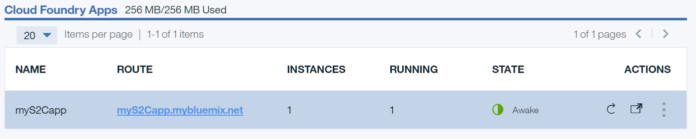

1. Select the gear icon in the upper right hand corner. Using the credentials from step 5, enter the following information. For ***Device Type***, use *gateway*. Use the same ***Device ID*** used in step 6. Click ***Save changes***.

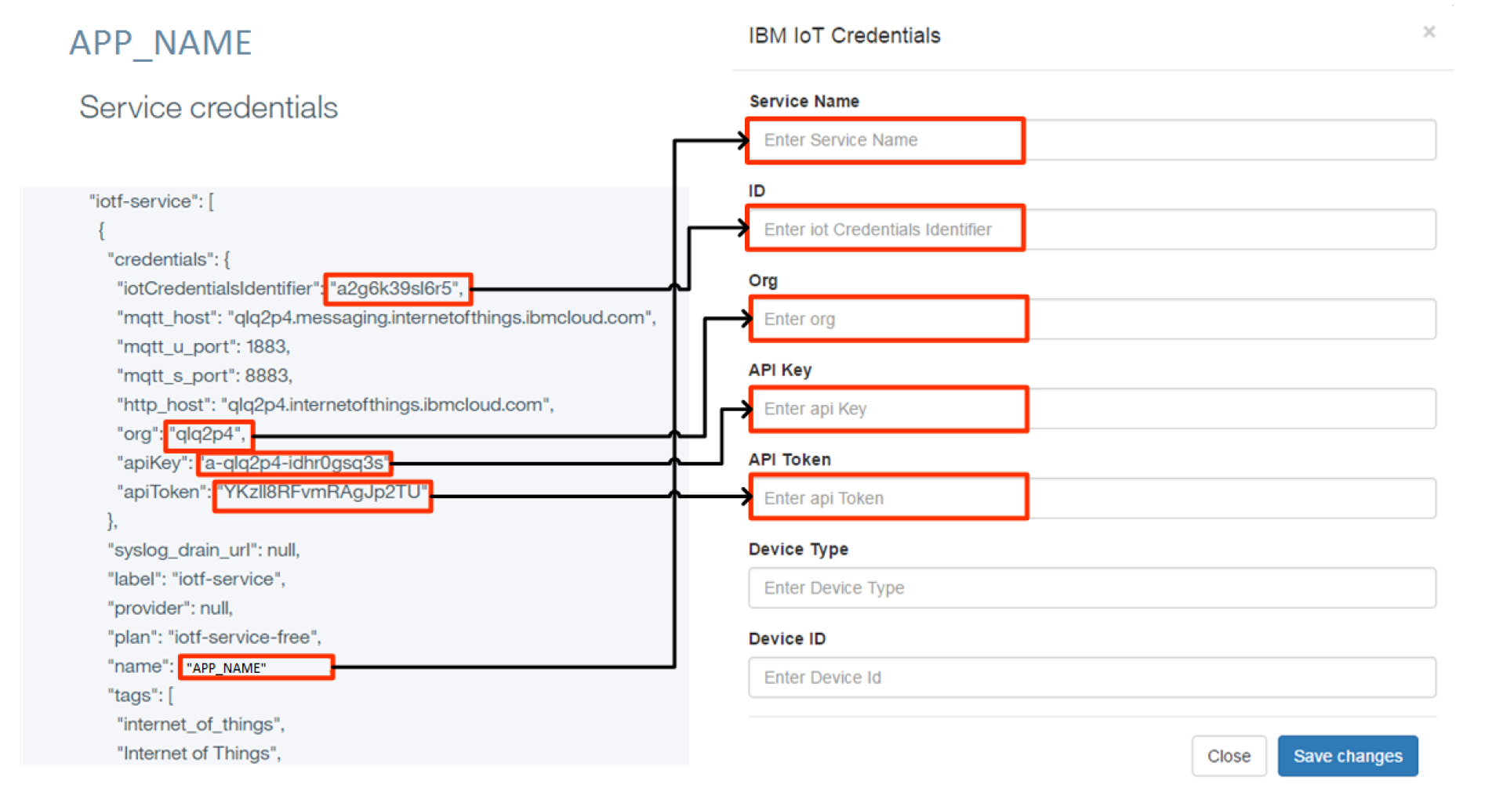

1. Select ***open*** to allow the sensor(s) to join the network.

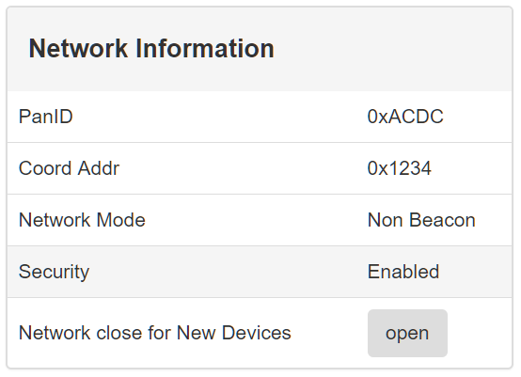

1. Power on the sensor(s), if not done so already.
   * The sensor(s) will automatically join the network.

Selecting ***Local Gateway*** will start a countdown timer from 30 seconds. When the timer expires, the page will automatically redirect to the **TIMAC CollectorApp**.

**Running Local Gateway**

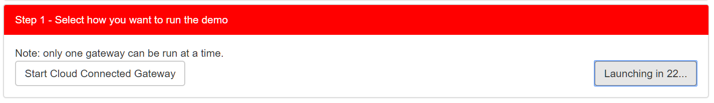

1. Select ***open*** to allow the sensor(s) to join the network.



1. Power on the sensor(s), if not done so already.
   * The sensor(s) will automatically join the network.

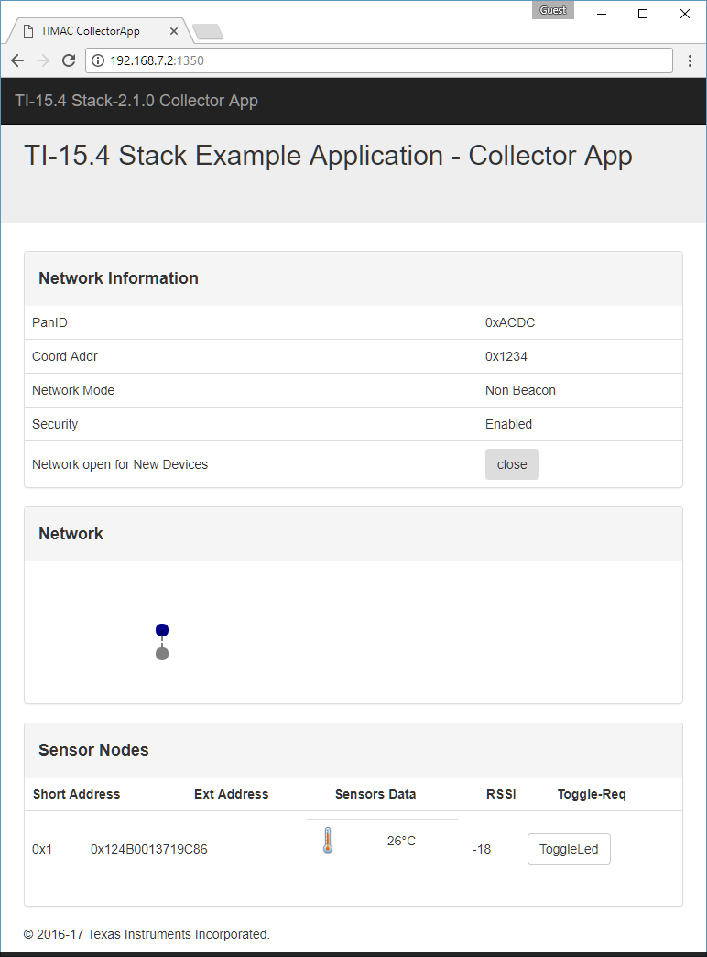

***Sensor will not join the network.***

**Troubleshooting**

Toggle the option to “open” the network for sensors through the web interface. This will ensure the network is open.

Sensors use non-volatile storage to remember previous networks. Press and hold ***BTN-2/DIO014*** and toggle the ***Reset*** button. This will clear the non-volatile storage and will cause the sensor to search for new networks.

